Ch - 1 : Understanding HDFS

1) What is HDFS ?
- HDFS – Hadoop distributed File System
- HDFS consists os a NaneNode and a Datanode
- HDFS was built under the premise that hardware will fail
- Fault Tolerance
  - Ensures that when hardware fails, users will still have their data available. Fault tolerance is achieved through storing multiple copies throughout cluster.
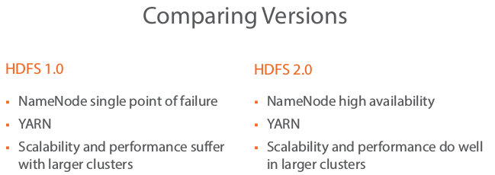
- YARN :
  - Split the role of the of the resource manager into global resource manager and application master

- .

